**SWARM SERVICE**

* Now we want to run a service on the swarm.
* So we want to run a specific container on all these nodes.
* To do that we will use a docker service command which will create a service for us that service is nothing but a container.
* We have a replicas here when one replica goes down another will work for us. Atleast one of the replica needs to be up among them.

**Step1:** Firstly we need to server so we create the server **in amazon linux** . After connect and also edit the security groups give **the all trafic allow**.

* sudo su –
* yum install docker –y
* systemctl start docker
* hostnamectl hostname manager **( here give the host name)**
* hostname manager
* docker swarm init

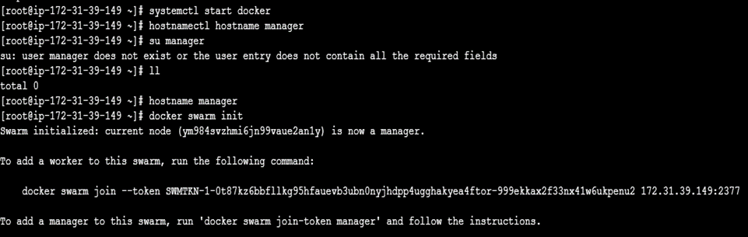

**Step2**: Now create the **slave servers 1&2** and edit security groups and give the **all traffic**. Both two **slave servers same process**.

* Sudo su –
* Yum install docker –y
* Systemctl start docker
* Here we have used the **(manager swarm init )** copy here
* Docker ps

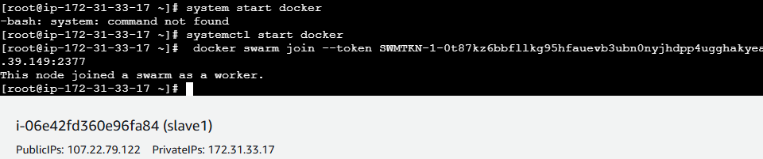

**Step3:** After run **manager server**

* **Create the service**
* docker service create the –name zomato --replicas 3 -- publish 80:80 httpd
* **raham : service name replicas : nodes publish : port reference image: apache**
* docker ps **(To see the continers)**
* docker service create the –name swiggy --replicas 3 -- publish 81:80 httpd
* docker ps
* docker service create the –name ahaa --replicas 3 -- publish 82:80 httpd
* docker service ls **( see the all services)**

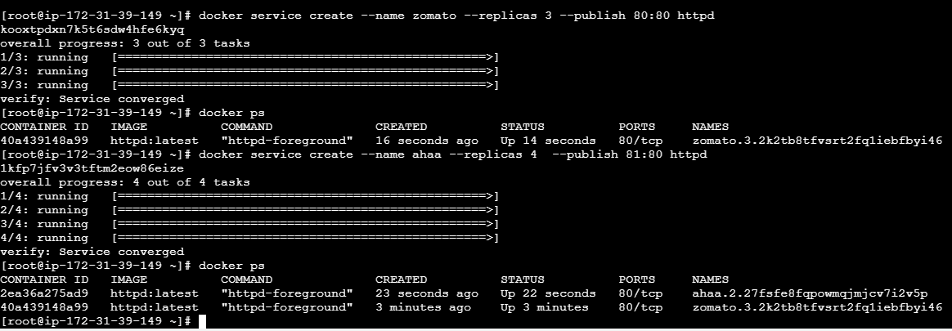

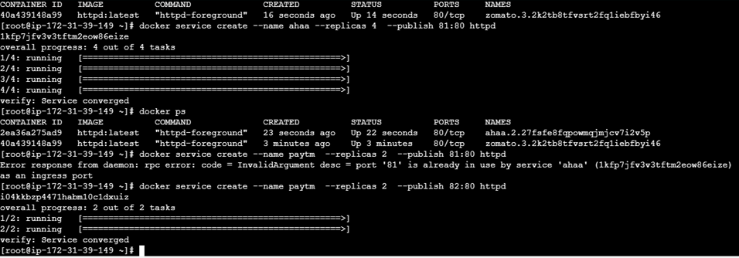

**Step4:** Here check the **slaves server1** are running or not

* docker ps

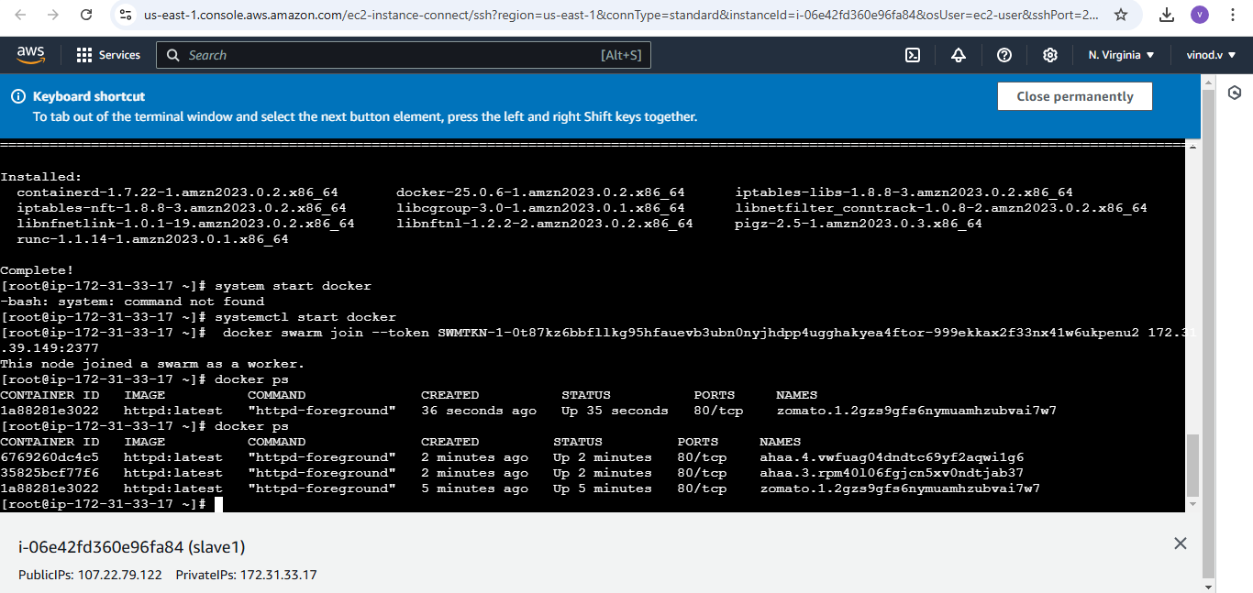

**Step5:** and also check **slave2**

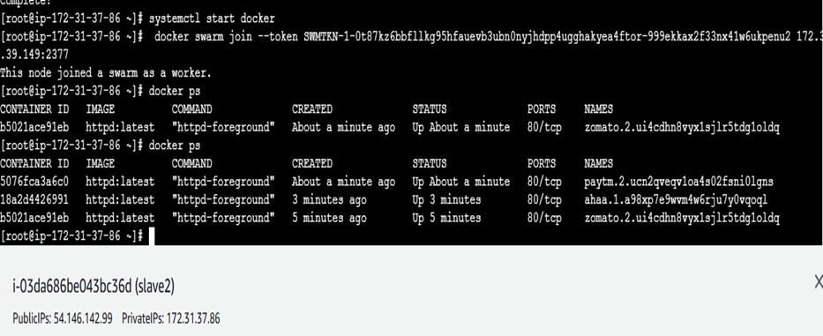

* **both slave servers are running rhe service manager at a time**

**Step6:** Now here chek the application status using **publicIP & port number like (81).**



**Step7:**create the docker image.

* Vi Dockerfile

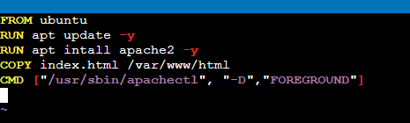

* Vi index.html
* Go to web html page for login and try your self modefiy heading.
* Docker build -t image .
* Docker service ls
* Docker images

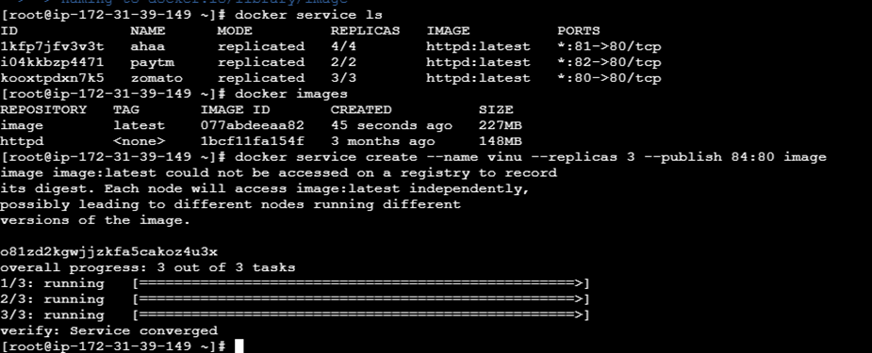

* Using Ipaddress accees the service here

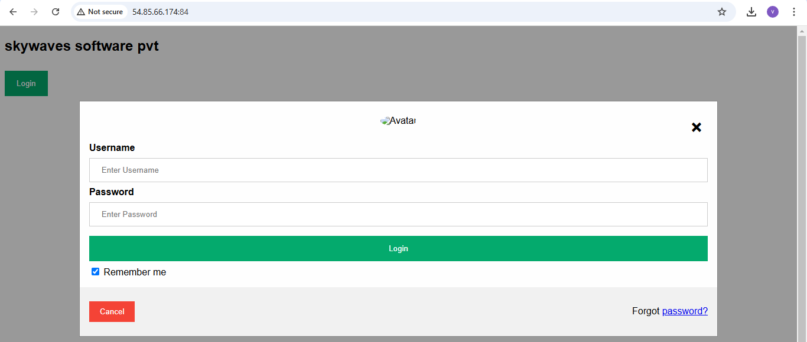

**Step8: Doker login in manager server**

* **Docker login**

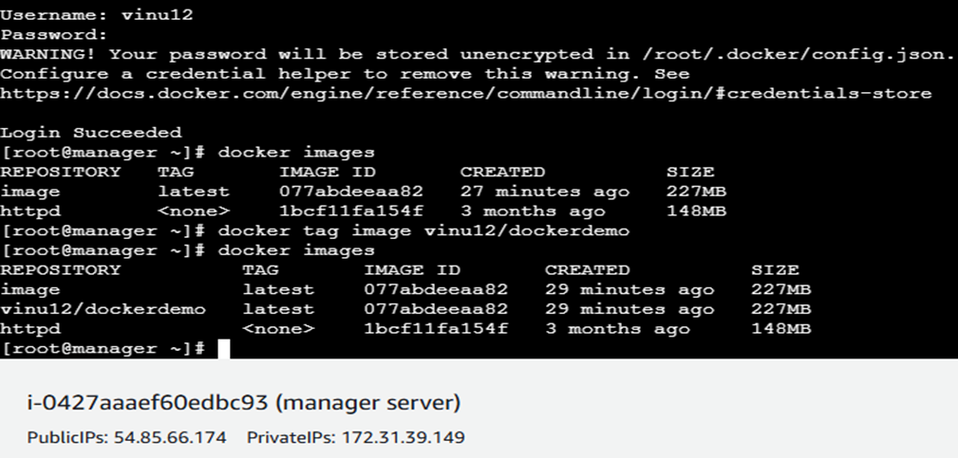

* docker tag image (**username/reponame docker hub) copy and paste**
* docekr images
* docker push **( reponame copy)**

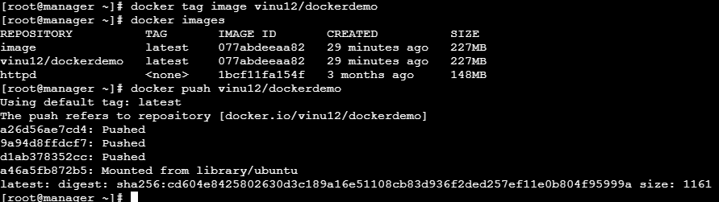

**Docker pushing is done**

